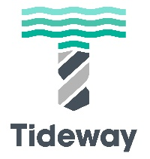
Thames Bridges Trek – 9 September 2023
How to create your fundraising page for The Felix Project and Time and Talents

1 Go to https://donate.giveasyoulive.com/corporate/tideway/thames-bridges-trek-2023
2 Click on ‘Start Fundraising’ button.
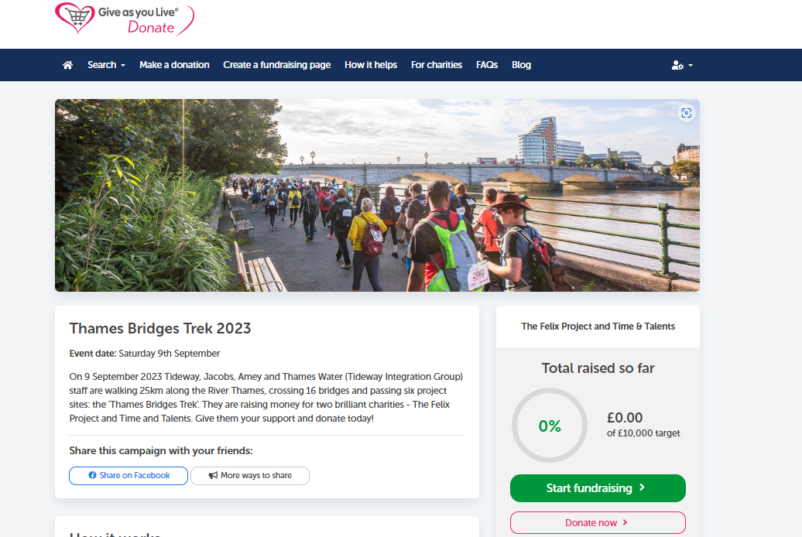
If you have not previously registered with Give As You Live, you will be asked to register as a (free) Member and you will see the screen below, please complete these details. You may have to go back into the Tideway ‘campaign’ page above after completing your registration.
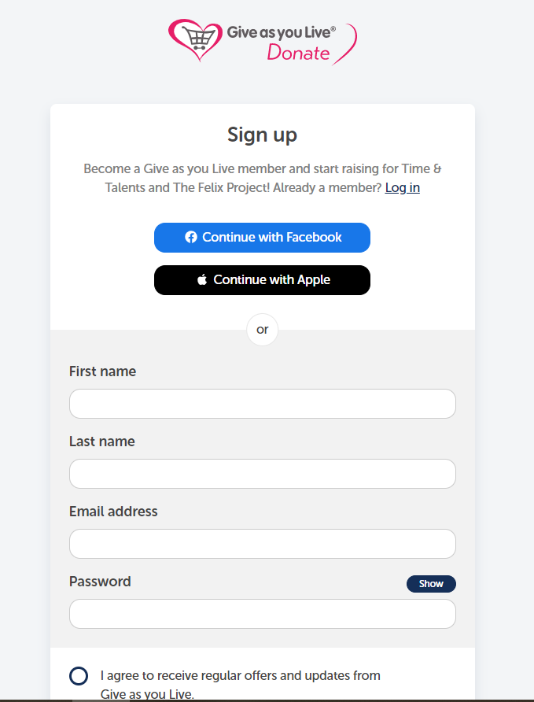
3 Create your Page Title – this will become the default web address
This can be whatever form of words you want, for example your name or team name
4 Choose a target
For one person this should be at least £100. For a page for two people, it should be at least £150 and for three people it should be at least £200. Or you can choose another amount.
5 Click ‘next’
6 Are you fundraising for a group?
If so, click the button to the right of your name
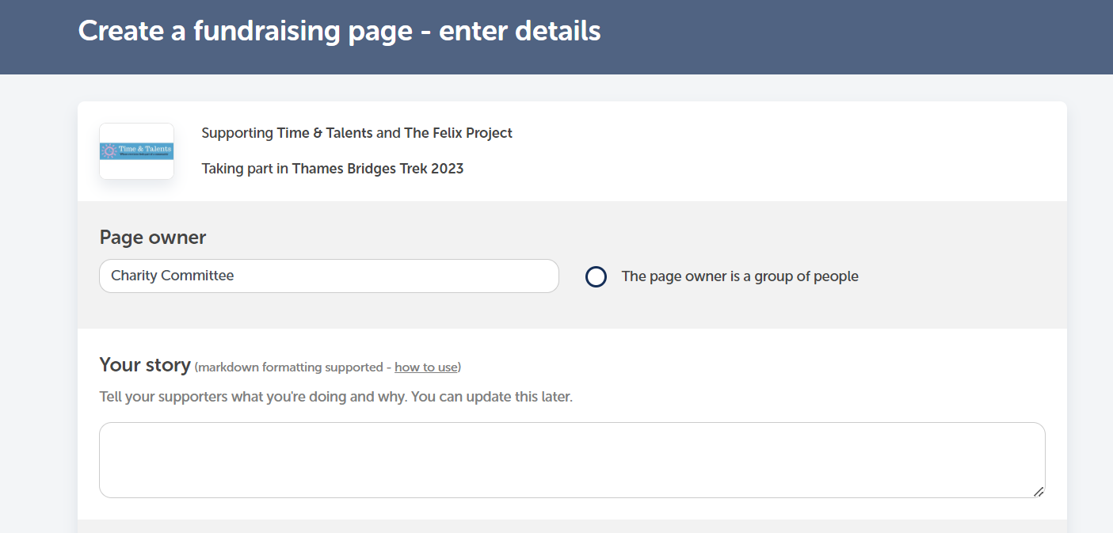
7 Tell your story – give more info about the challenge
Write a few words about the challenge and why you are doing it. if you are looking for some generic wording about the event, feel free to use the wording below.
“On 9 September 2023 I am /we are walking 25km along the River Thames, crossing 16 bridges and passing six project sites in the 'Thames Bridges Trek'. I am / we are raising money for two brilliant charities - The Felix Project and Time and Talents. Give me / us your support and donate today!”
8 Add images, videos and other links. If you are looking for a generic Thames Bridges Trek image that should fit the format of the page, you can use the one below, but you can also use the generic images offered by Give as You Live or choose your own.
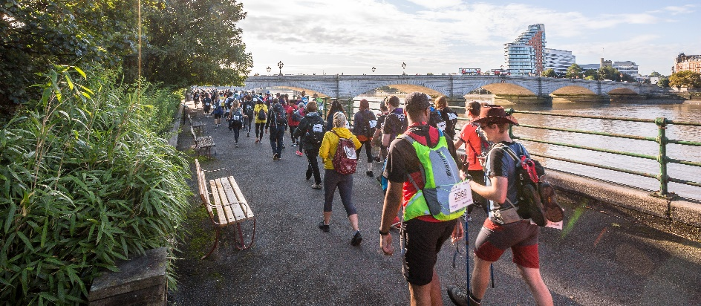
9 Gift Aid, privacy and Ts and Cs
This event does qualify for Gift Aid, so please answer ‘no’ to the two questions.
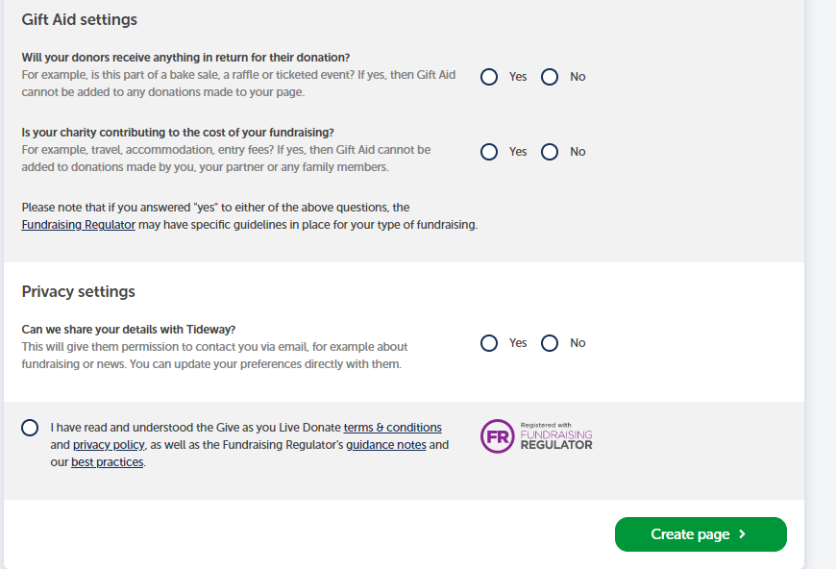
Tideway will have your details as a result of your registration for the event so you do not have to click yes to Privacy question (though it is fine if you do)
10 Click ‘create page’.
Your fundraising page is now complete!
Please be proud of the event you are doing and share your page on social media sites like Facebook and Twitter to raise awareness of your fundraising efforts.

Good luck – and thank you

